**Project Design Phase-II**

**Technology Stack (Architecture & Stack)**

|  |  |
| --- | --- |
| Date | 03 October 2022 |
| Team ID | PNT2022TMIDxxxxxx |
| Project Name | Project - xxx |
| Maximum Marks | 4 Marks |

**Technical Architecture:**

The Deliverable shall include the architectural diagram as below and the information as per the table1 & table 2

**Example: Order processing during pandemics for offline mode**

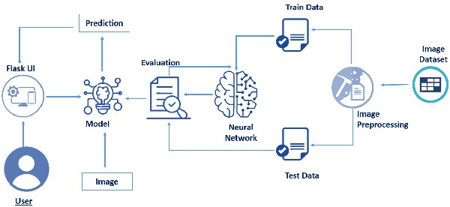

**Table-1 : Components & Technologies:**

|  |  |  |  |
| --- | --- | --- | --- |
| **S.No** | **Component** | **Description** | **Technology** |
|  | User Interface | How user interface that allows you to do interactions with systems via graphical input and audio. | Python. |
|  | Application Logic | Logic for a process in the application | Java / Python |
|  | Database | Data Type, Configurations etc. | MySQL, NoSQL, etc. |
|  | Cloud Database | Database Service on Cloud | IBM Cloudant |
|  | File Storage | File storage requirements | IBM Block Storage or Other Storage Service or Local Filesystem |
|  | Machine Learning Model | CNN(Convolutional Neural Network processes these images and identifies them on the basis of certain features) | Object Recognition Model. |
|  | Infrastructure (Server / Cloud) | Application Deployment on Local System / Cloud  Local Server Configuration:  Cloud Server Configuration : | Local, Cloud Foundry, Kubernetes, etc. |

**Table-2: Application Characteristics:**

| **S.No** | **Characteristics** | **Description** | **Technology** |
| --- | --- | --- | --- |
|  | Open-Source Frameworks | List the open-source frameworks used | Python flask |
|  | Security Implementations | Mail id and Password | Encryptions |
|  | Availability | Justify the availability of application (e.g. use of load balancers, distributed servers etc.) | Image recognition and real time captioning |
|  | Performance | Design consideration for the performance of the application (number of requests per sec, use of Cache, use of CDN’s) etc. | Deep Learning |